Assigning new Leadership codes to SLT members in FPS

We now have separate codes for members of the senior leadership teams. These are 0200, 0208 and 0209.
To assign these codes to your SLT members in FPS, you will first have to set up the new codes in FMS (you will have received guidance on this separately).
Then you can import them into FPS via the web companion.
Once this has been done you can assign them in one of two ways, either individually change the codes for each employee under their account coding details. This would be best if you only have a small senior leadership team.
For those with larger numbers you may find it quicker to set up a new job type and assign the codes from there.
In order to do this you will need to set up the job type first, log in to FPS and before you open a scenario go to the menu, click on Job Types and then insert job type. This will bring up a window in which you can insert the details and coding for SLT members.
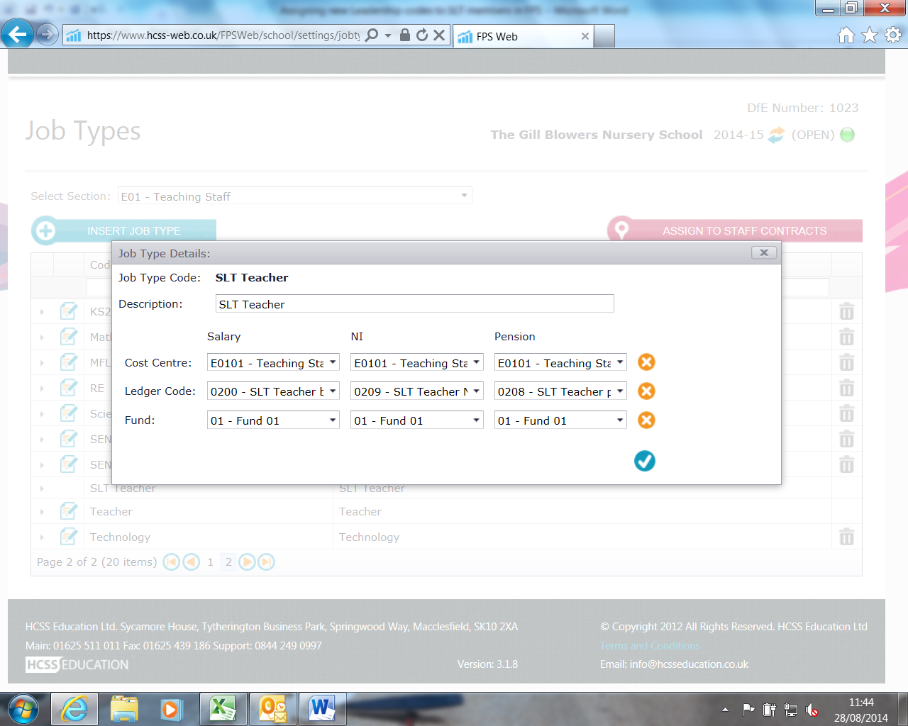
Once this has been done you will need to go to your scenario and update all SLT contract details with the job type code you used. If you edit the contract details on the top left of the contract screen you will be able to pick the job type code you used from the drop down box. Once you have updated all relevant contracts close the scenario.

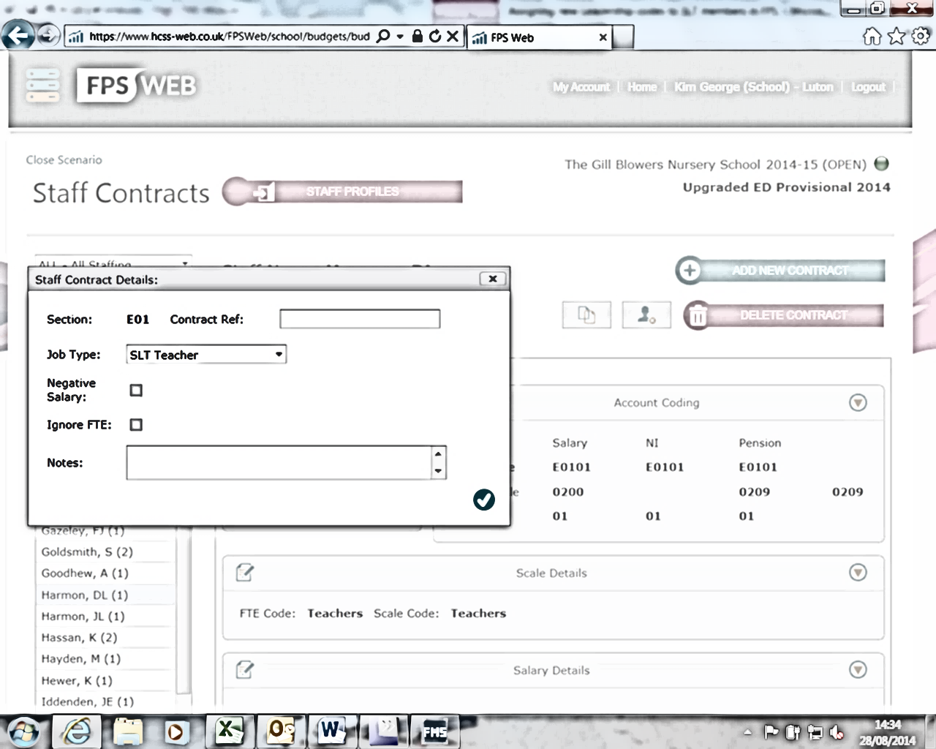You can then go back to the original menu and pick Job Types again, this time click on assign to all contracts and when the window opens pick E01 Teaching Staff and the new job type you set up.
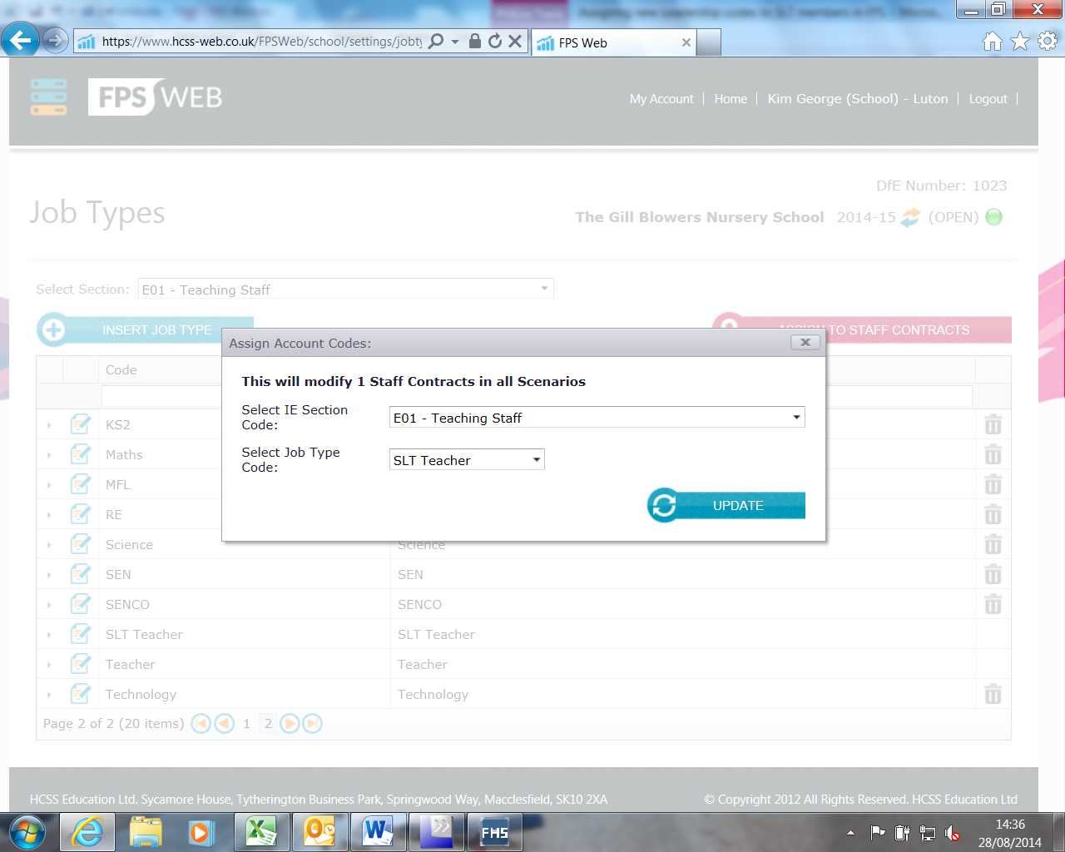
You will now be able to see how many contracts you are modifying, click update and the codes will be changed.

